**Shapley - 22 Features (FI 0.55)**

Considering Shapley Feature importance values ≥ 0.55.

**Features:** FC3, Fz, F7, FT7, T4, T3, Fp2, Fp1, TP7, CP3, F4, F8, F3, O2, O1, T6, Oz, FT8, PZ, T5, FCZ, C4.

**Machine learning evaluation using 22 Features with Feature Importance ≥ 0.55.**

|  |  |  |  |  |  |  |
| --- | --- | --- | --- | --- | --- | --- |
| Model | Accuracy | Precision | Recall | F1-score | AUC-ROC | Training Times (s) |
| KNN | 0.998339 | 0.999019 | 0.997655 | 0.998337 | 0.998338 | 0.08 |
| Random Forest | 0.991171 | 0.996083 | 0.986214 | 0.991124 | 0.991169 | 493.67 |
| XGBoost | 0.946919 | 0.962356 | 0.930180 | 0.945995 | 0.946912 | 6.02 |
| Decision Tree | 0.919306 | 0.922425 | 0.915544 | 0.918971 | 0.919304 | 41.09 |
| Extra Trees | 0.995286 | 0.998418 | 0.992141 | 0.995269 | 0.995285 | 128.71 |

**Table:** Machine learning evaluation using 22 Features with Feature Importance ≥ 0.55.

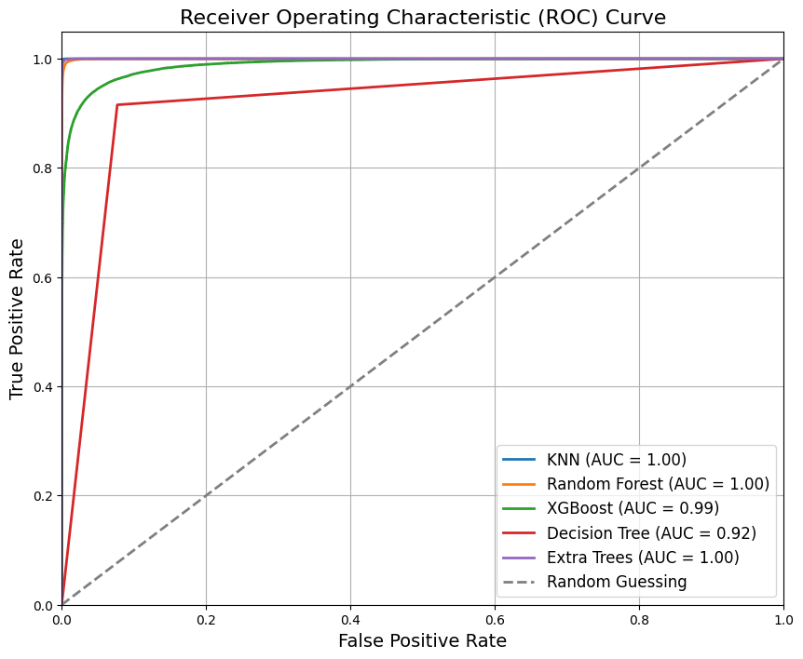

**Figure:** ROC Curve for Machine Learning Results using 22 Features with Feature Importance ≥ 0.55.

**Classification Reports - 22 Features**

**KNN:**

**precision recall f1-score support**

0 1.00 1.00 1.00 77676

1 1.00 1.00 1.00 77614

accuracy 1.00 155290

macro avg 1.00 1.00 1.00 155290

weighted avg 1.00 1.00 1.00 155290

**Random Forest:**

**precision recall f1-score support**

0 0.99 1.00 0.99 77676

1 1.00 0.99 0.99 77614

accuracy 0.99 155290

macro avg 0.99 0.99 0.99 155290

weighted avg 0.99 0.99 0.99 155290

**XGBoost:**

**precision recall f1-score support**

0 0.93 0.96 0.95 77676

1 0.96 0.93 0.95 77614

accuracy 0.95 155290

macro avg 0.95 0.95 0.95 155290

weighted avg 0.95 0.95 0.95 155290

**Decision Tree:**

**precision recall f1-score support**

0 0.92 0.92 0.92 77676

1 0.92 0.92 0.92 77614

accuracy 0.92 155290

macro avg 0.92 0.92 0.92 155290

weighted avg 0.92 0.92 0.92 155290

**Extra Trees:**

**precision recall f1-score support**

0 0.99 1.00 1.00 77676

1 1.00 0.99 1.00 77614

accuracy 1.00 155290

macro avg 1.00 1.00 1.00 155290

weighted avg 1.00 1.00 1.00 155290

**Confusion Matrix - 22 Features**

